SKELETAL STRUCTURES IN PORIFERA
Skeletal structures of sponges are spicules and spongin fibres. Spicules are formed by carbonates of lime or silica in the form of needle like pieces. Spongin fibres are composed of a silk-like scleroprotein.
SPICULES
The spicules constitute major part of skeletal system, which are secreted by special mesenchymal cells called scleroblasts. They are in the shape of spines or rays that radiate from the centre. Spicules possess a core of organic material around which is deposited either calcium carbonate or silica.
On the basis of the material they are formed of, spicules are of two types: Calcareous, made of calcium carbonate and characteristic of the class Calcarea and Siliceous, made of silica and characteristic of the class Hexactinellida.
According to the size, spicules are classified into two major types: Megascleres, which are large-sized and constitute main supporting framework of sponge body and Microscleres, which are smaller in size and occur in the mesenchyme.
Based on the number of axis present in the rays spicules may be of three types: monoaxon, triaxon and polyaxon.
Monaxon: These spicules grow along a single axis. These may be straight needle-like or rod-like or may be curved. Their ends may be pointed, knobbed or hooked. If spicule has only one pointed end it is called Monoactinal. If there are two points it is called Diactinal. Amphidisc are spicules which have disc at both ends.
Triaxon: Triaxon spicule has three axes that cross one another at right angles to produce six-rays. These are found only in class Hexactinellida.
Tetraxon spicules consist of four rays radiating from a common point. Triradiate are also tetraxons in which one of the four rays is lost. In Calthrops all rays are equal.
Polyaxon: In this type of spicules, several equal rays radiate from a central point. They are common among the glass sponges.
FORMATION OF SPICULES
The spicules are secreted by specialized mesenchyme cells known as scleroblasts. Scleroblast secreting a calcareous spicule is called calcoblast while that producing a siliceous spicule is called silicoblast.
Monaxon spicules are formed because of the incomplete division of scleroblast cell giving rise to binucleate scleroblast. The two nuclei begin to move away from each other and calcium carbonate from sea water begins deposit in between the space of two nuclei in the form of an axis. As the calcium carbonate needle between the two nuclei begins to lengthen, the cell divides into two, the founder cell and the thickener cell. When the spicule is fully formed both the cells detach and wander off into mesenchyme. Triradiate spicules are secreted by three scleroblast cell which come to lie in a triangular manner.
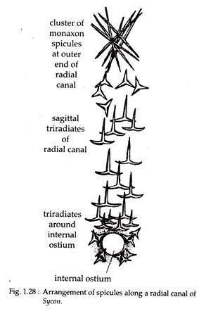
SPONGIN FIBRES
Spongin is an organic horny, elastic substance consisting of scleroprotein that is rich in sulphur and is chemically similar to collagen and sericin. It contains hydroxyproline and glycine in large proportions and also contains glucosamine, glucose, galactosamine and galactose mannose, fucose, arabinose and uronic acid. Spongin is insoluble in water and acids but soluble in KOH. It is chemically inert and cannot be digested by the digestive enzymes. Spongin contains a large amount of iodine, up to 14% in certain tropical species.
STRUCTURE AND GROWTH OF SPONGIN
Spongin fibres are made of an axial core or medulla that is 10-50 micron wide, surrounded by helically coiled elementary fibrils which are secreted by the spongioblast cells derived from the mesenchyme. The spongioblast cells arrange themselves in rows and develop a vacuole within which spongin material is collected. Later, spongin secreted by each spongioblast cell fuses with the neighbouring cells to form long fibres. Spongin fibres form a mesh work to provide firmness to the sponge body.

